Name: ________________
Unit 3
Organic or Traditionally Grown Food
GM Foods Yes or No
Food Industry Safe or Not
How do Foods Change our Lives?
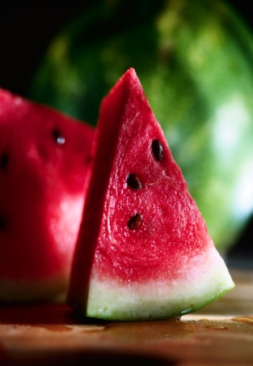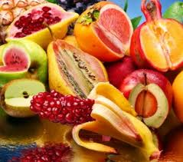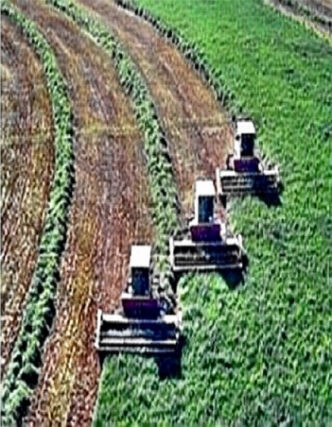

1. _____ 7. _____
2. _____ 8. _____
3. _____ 9. _____
4. _____ 10. _____
5. _____ 11. _____
6. _____ 12. _____
Extra Credit - _____ Message to the Instructor - ______________________
Total Points for Unit 2 = 650 Unit 3 Grade _____ X .15 = _____
Reading and Research:
- Read one of the following books: Cod, A biography of the Fish that Changed the World; Banana, The Fate of the Fruit that Changed the World; Tomatoland, How Modern Industrial Agriculture Destroyed our most Alluring Fruit; Food Justice (Food, Health, and the Environment); OR Organic Foods: What You Didn’t Know and Fast Food (Junk Food USA: “Paying for What You Eat”). 100 pts.
- Take part in a book discussion from the book you read. You need to speak at least five times and have resources with you to support your ideas. 20 pts.
- Watch the video Food, Inc. and take part in a discussion to follow. Topics such as altered seeds, locally grown, and ethically grown food will be discussed. 20 pts.
- Select a topic for your research and create a portfolio of information to adequately develop the topic. It should include definitions, examples, charts and graphs, articles, statistics, visuals, and others research on the topic. This portfolio can be presented through a website, PowerPoint, portfolio, etc. and must include at least 10 items. All materials should be cited and current in nature. 100 pts.
- Watch the video How I Fell in Love with a Fish.
- Everyone will read the novel The Jungle by Upton Sinclair. While reading the book the student will do the following: 1. Take notes in the book and print your notes, 2. Create 10 essential questions in the note section and print, 3. Send 10 messages on social media discussing concepts or passages about the book topic and print, 4. Create a 20 point list of the major points of the book, 5. Write the thesis of the work, and the counterargument, if there is one, and print, 6. Print 10 quotes from the book that you think are important to the thesis or you think are well written, 7. Create or “cut and paste” an outlined biography of the author (one page) and then print. 100 pts.
- Watch the video Fast Food Nation and participate in the discussion of the video. 20 pts.
- Prepare an oral presentation on the topic of your choice and give a 15 minute presentation on the topic. The presentation must be presented in front of the class and be taped. A reference page of research (visual and printed) must be included with all the sources utilized. The presentation also must include 10 visuals. 100 pts.
- Perform a deconstruction of two articles. The questions will deal with main thesis, reasons presented, counter argument, validation of the author, and evaluation of the argument. 50 pts.
- Select a video for the class to explore on your topic. The video should be 5 to 10 minutes in length. The video should be 5 to 10 minutes in length. A list of ten important points the video presents is required with the title and citation for the video. Send your name, the title of the video, and a link to the video to the instructor. 20 pts.
- Organize the essay you plan to write. An essential question and a thesis need to be written. Sources should be copied that you plan to use and placed on a word document. A cited reference sheet with full and in body references will be included. This needs to be approved by the instructor. 20 pts.
- Write a 1750 to 2000 word essay on your topic. The essay must include an essential question, a thesis, supported research, and a reference sheet. 100 pts.

